Autumn Term 2021 The Vikings and the Anglo Saxons St Etheldreda class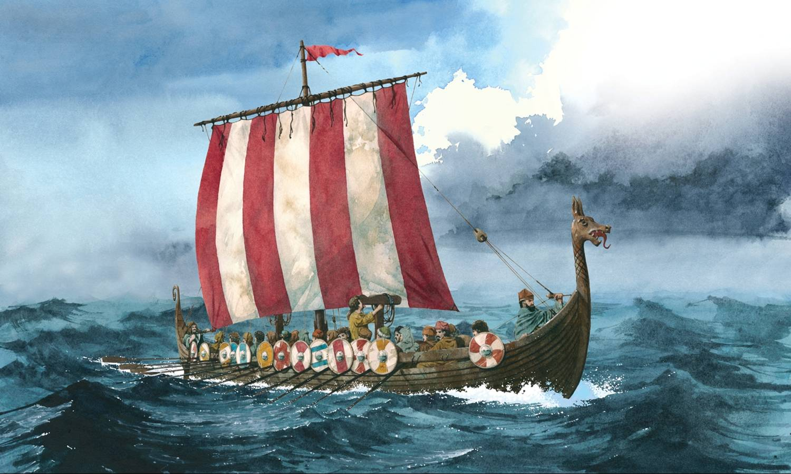
RE
Harvest and Christmas
Christianity
People of God
What is it like to follow God?
Science
Rocks and classifying materials.
Computing
ICT safety
Scratch for coding
ICT skills using word

English Narrative writing based on legends and folk tales.
Poetry – kennings and Viking poetry
Non-fiction based on mountains and Vikings. Instruction writing.

Geography
Mountains
Earthquakes

PE
Hockey
Netball
Tag rugby
Gym- lead and follow

Music
Harvest and Christmas songs.
Livin’ on a prayer
Jazz
Djembe and ukulele playing

Art/DT
Runes
Kandinsky – collage
Lowry – representing ordinary people
Viking longboats
PSHE
Beginning and Belonging
Family and Friends
Kindness week

History
How did the Vikings and Anglo Saxons shape the England we know today?

Maths
Place Value
Addition and Subtraction
Multiplication and Division
Money

