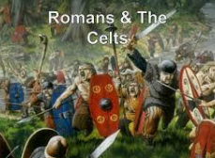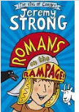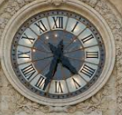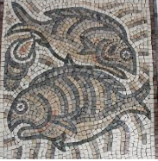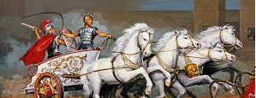
ICT
Data and information collection and presentation. Scratch for coding
Art
Roman themed art; mosaics and frescos.
St Etheldrea’s Class Spring 2020
English – Daily Guided Reading sessions. Romans on the Rampage by Jeremy Strong. Poetry, Fiction and Non Fiction texts. Please read every day and continue to practise spellings for homework.
Maths – multiplication and division, measurement, fractions and decimals (year 4 only). Please continue to practise quick recall of number facts and times tables for homework.
History
The Celts and the Romans. Looking at historical evidence and enquiry. Comparison of how life changed and developed over time.

Science
The circulatory system.

Music Ukulele, xylophone playing to learn about notation, composition.
Songs and music for Easter.

PSHE
Drug Education-Life Education Bus. Diversity and communities.

RE
Creation. Fall. Easter.

PE
Hockey and Netball in preparation for tournaments.

