Literacy
- Write a story set in Roman times.
- Create an estate agents’ leaflet to sell a Roman villa.
- Write a newspaper report about the volcanic eruption on Pompeii.
- Produce a Non-Chronological report on an aspect of Roman life.

Geography
- Find Rome in an atlas or on a map and write a visitors’ guide.
- Research the Roman Empire and create a fact sheet.
- Write a weather report for Rome.
Art
- Draw or create a mosaic.
- Design a Toga.
- Design a Roman shield.
- Draw or paint a Roman scene.

Maths
- Can you learn the Roman Numerals?
How far can you go?
- Make a symmetrical mosaic. What shapes have you used?
- Plan a cost a holiday to Rome for your family.
What did the Romans ever do for us?
KS2 Termly Homework Pick and Mix.
Choose 1, 2 or more of the activities to complete and bring in during wk beginning Mon 9th March.

D&T
- Build a Roman villa.
- Build a Roman chariot.
- Design a Roman sandal.
- Research a Roman menu.
- Put together a powerpoint of an aspect of Roman life.

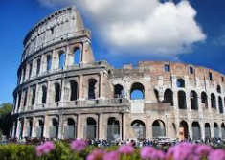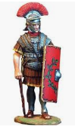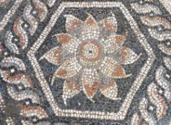
Use your imagination...make some jewellery, research the society, be inspired!

