

Intent
Small School. Big Hearts. Big Ambitions

Maths Statements
I pray that your love for each other will overflow more and more, and that you will keep on growing in knowledge and understanding. Philippians 1:9

Maths is a key life skill; an integral part of everyday life. We aim to prepare the children for a rapidly changing world. Maths is essential; critical to science, technology and engineering, necessary for financial literacy and the world of employment.
We want children to see themselves as confident, fluent mathematicians who are able to reason and problem solve and apply these skills across the whole curriculum.
We want to children to have both a deep understanding and be able to explain their thinking. To develop their resilience and acceptance that errors are often a necessary step in our learning.
The National Curriculum for mathematics aims to ensure that all pupils:
♣ become fluent in the fundamentals of mathematics, including through varied and frequent practice with increasingly complex problems over time, so that pupils develop conceptual understanding and the ability to recall and apply knowledge rapidly and accurately.
♣ reason mathematically by following a line of enquiry, conjecturing relationships and generalisations, and developing an argument, justification or proof using mathematical language
♣ can solve problems by applying their mathematics to a variety of routine and non-routine problems with increasing sophistication, including breaking down problems into a series of simpler steps and persevering in seeking solutions.

Our aim is for every child to become independent, inquisitive, creative, numerically literate, confident and financially responsible.

Implementation
Maths is at the forefront of our curriculum. From EYFS to Year 6, we systematically build on the sequence of lesson objectives, ensuring there is progressive coverage throughout the school. Our curriculum is developed in a mastery style, allowing the children to evolve deep conceptual understanding of Maths and giving them equal access to the curriculum, no-matter their starting point.
We teach a daily Maths lesson following the National Curriculum programme of study and utilising the structure of the White Rose Maths Scheme.
- We practice our multiplications facts (KS2) and KIRFs (Key Instant Recall Facts) to develop automaticity to become problem solvers of the future.
- We believe that fluency is essential so that children are able to make links between key concepts.
- We encourage resilient learners who recognise that mistakes are a step in their learning journey.
- We deliver high quality teaching and learning experiences that foster and nurture positive and enthusiastic attitudes.
- We develop children’s ability to work both independently and collaboratively as part of a team, using talk partners. Through mathematical talk, children will develop the ability to articulate and discuss their thinking, reasoning and problem solving.
- We model and encourage the use of mathematical vocabulary and stem sentences (You can find these in the Maths section of our website).
- We use NRICH and Gareth Metcalf’s ‘I See Reasoning’ and ‘I See Problem Solving’ materials providing opportunities to identify and recognise patterns and rules; learning the why.
- We use a range a concrete materials (resources like cubes, counters and Numicon) to develop understanding:

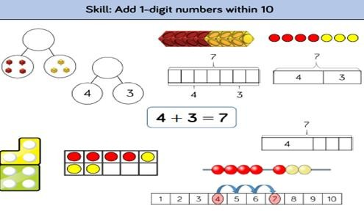

We want children to ask themselves:
Can I make it? - use resources to model the Maths they are working on Can I say it? - use mathematical vocabulary confidently
Can I draw it? - record mathematics in a variety of ways; charts/ tables/ diagrams
Can I write it? - understand and record mathematical symbols and number sentences

- We plan to support all learners (including those with SEN and EAL) through differentiated questioning, scaffolding and resources, whilst deepening their understanding in each strand of Maths.
- We promote and celebrate Maths throughout the school and local community, for example, the weekly estimation station challenge.
- We use regular and ongoing assessment to inform teaching and intervention, to support and enable the success of every child.

Impact
The impact of our whole school Maths curriculum is that all of the children become confident and able mathematicians who can navigate the world beyond school, from calculating the cost of their lunch to balancing their family finances.
Impact is monitored through children’s work in books and online learning journeys, reflections and teacher assessments. Teachers provide verbal and written feedback, and ‘pupil voice’ is gathered through interviews to ensure our curriculum is centered on the needs of our children.

