Small School. Big Hearts. Big Ambitions

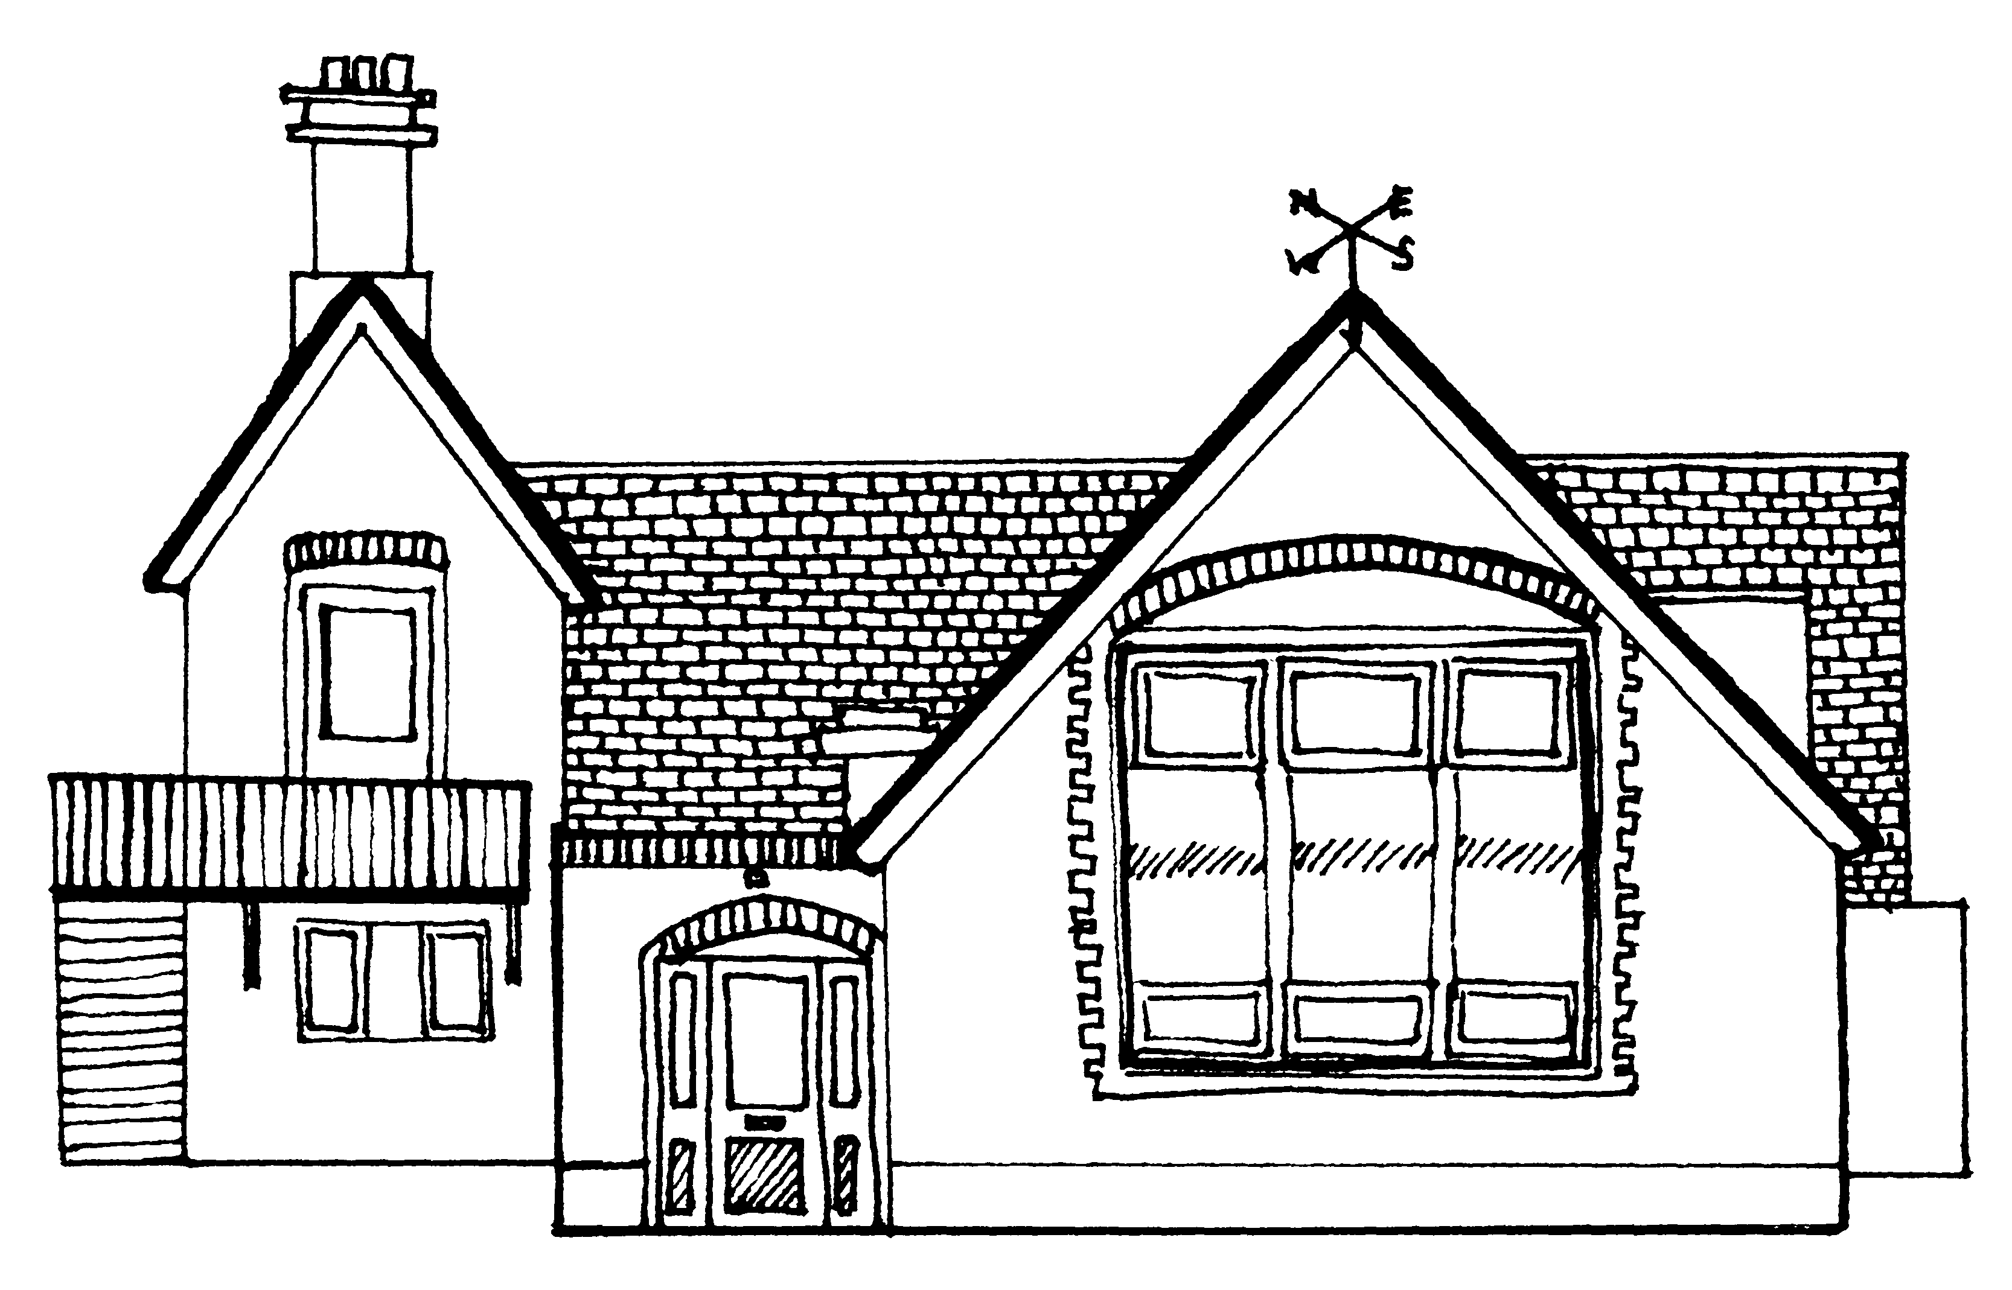
Dry Drayton Mathematical Vocabulary

Principle – The idea is that children are taught to use the correct mathematical language to reason. This will also support them in understanding concepts when shown alongside images and manipulatives, such as dienes and bar models.
Practice – All teachers and children in all year groups, will use the same (accurate) mathematical language to describe concepts. This will ensure consistency for children as they move up our school.
Place Value | Addition & Subtraction | Multiplication & Division
- …is the whole. … is a part and …. Is a part  - ‘4’ is made up of ‘3’ and ‘1’ Four is one more than 3  - There are __ tens and __ ones. The number is  - The value of the tens/one digit is __.  - In the base 10 system, 10 _____ is equal to 1 ______.  - The highest value digit you can have in one column is 9.  - When we have 10 in one place value column, we exchange for 1 of the next column up.  - When comparing numbers’ values, look at the greatest place value column first.  - Rounding finds which is closer. If it is exactly in the middle, round up.  - A 0 can be used as a place holder, showing that place has no value.  - A decimal point separates whole numbers from decimal numbers  - A decimal number has a value greater than 0 and less than 1  - A negative number has a value less than 0.  - Odd numbers cannot be shared or grouped equally between 2 to give whole numbers.  - Even numbers can be shared or grouped equally between 2 to give whole numbers. | - First…then…now  - If we change the order of the numbers, the answer always stays the same (addition)  - When I add multiples of ten, the tens go up and the ones stay the same.  - When I subtract multiples of ten, the tens go down and the ones stay the same.  - Addition is when two or more parts combine together to make a whole  - Subtraction is either taking away one or more part from the whole  Or  the difference between two values  - In addition, we can partition the values differently but the whole must stay the same.  - In subtraction, we can partition the values differently but the difference must stay the same.  - When using column addition or subtraction, always start at the lowest place value column. | - There are ….equal groups with … in each group.  - Multiplication is repeated addition.  - Division can be repeated subtraction  - Division is either sharing equally into a set number of groups  Or Creating groups of the same value  - Factors multiplied together make a product  - An array is set of objects in equal rows and columns  - A multiple is a number in that multiplication table.  - A common multiple is a multiple that is shared by two or more numbers.  - A factor is a whole number that another whole number divides equally into.  - A product is the result of two factors multiplied together.  - When the factors of two or more numbers are the same ("in common"), then they are "common factors".  - Prime numbers are numbers that have only 2 factors: 1 and themselves.  - A prime factor is a factor that is a prime number.  - When dividing by _______, the number’s value gets _______ times smaller  - When dividing by ____, move _____ place(s) down the place value chart  - When multiplying by _______, the number’s value gets _______ times greater  - When multiplying by ____, move _____ place(s) up the place value chart

Fractions/Decimals/Percentages | Measurement | Geometry
- A half is one of 2 equal parts of a whole 1/2  - A quarter is one of 4 equal parts of a whole 1/4  - A fraction is an equal part of a whole.  - The Denominator is the number of equal parts the whole has been divided into (bottom)  - The Numerator is the number of parts being used (top)  - The fraction bar represents division -  - A unit fraction has 1 in the numerator 1/5  - A non-unit fraction has a digit greater than 1 in the numerator 3/4  - An improper fraction has a greater numerator than denominator 13/10  - Equivalent fractions are fractions that have different numerators and denominators, but their value is the same. 2/4 = 3/6 = 4/8  - A mixed number has a whole number and a fraction 2 1/3  - A ______ is one of _____ equal parts that make a whole  - ¾ is 3 out of 4 equal parts  - A decimal point separates whole numbers from decimal numbers  - A decimal number has a value greater than 0 and less than 1  - per cent relates to ‘number of parts per 100’ and is represented by %  - percentages, decimals and fractions are different ways to represent values in proportion to each other | - The length is the longest side.  - The capacity is the maximum amount something can contain.  - The mass is the total matter (stuff) of the object.  - The perimeter is the total distance around the outside of a shape.  - The Area is the size of the surface on the inside of the perimeter.  - The hour hand is the shortest hand.  - AM begins at midnight and means ‘At Morning’  - PM begins at midday and means ‘Past Morning’ | - A regular shape has all equal sides and equal angles.  - An irregular shape does not have all equal sides and angles  - A shape with ____ sides is a __________.  - A 2D shape is flat and has 1 face  - A 3D shape is solid and has more than 1 face  - A vertex is a point where two or more curves, lines, or edges meet.  - Vertices is plural and means more than one vertex.  - Sides are the lines that join vertices in 2D shapes.  - Edges join vertices and faces in 3D shapes  - Faces are surfaces on 3D shapes.  - An isosceles triangle is a triangle with at least two equal sides  - An equilateral triangle is a special type of isosceles triangle  - A square is a special type of rectangle  - An angle is formed when two lines meet and its size is measured in degrees.  - A right angle is a quarter turn of 90 degrees.  - Acute angles are less than a right angle and less than 90 degrees.  - Obtuse angles are greater than a right angle and greater than 90 degrees but less than 180 degrees.  - Reflex angles are angles measuring greater than 180 degrees and less than 360 degrees.  - Lines of symmetry separate parts that mirror each other  - Perpendicular lines come in sets and meet at a right angle  - Parallel lines always stay the same distance apart and will never meet  - The horizontal axis is the ‘X’ axis  - The vertical axis is the ‘Y’ axis.  - When plotting co-ordinates, X comes before Y.  - The intersecting x- and y-axes divide the coordinate plane into four sections called quadrants.  - The reflection is the mirror image of a shape or object  - A translation is when a shape moves from one position to another without being rotated or flipped.  - Circumference is the distance around the edge of a circle – its perimeter.  - Diameter of a circle is any straight line that passes through the centre of the circle and whose end points lie on the perimeter.  - Radius of a circle is a straight line from its centre to the perimeter.  - Radius is always half the diameter.

Statistics | Algebra | Ratio and Proportion
- Discrete data is made up of separate values. They stand alone.  - Continuous data can take any value on a continuum. It is linked together.  - The horizontal axis is the ‘X’ axis  - The vertical axis is the ‘Y’ axis.  - When plotting co-ordinates, X comes before Y. | - Variable is an unknown number/value that is represented by a letter or symbol.  - Expression numbers and letters (or Symbols) grouped together to show the value of something.  - Equation a statement of equality (=) between 2 expressions.  - Simplify to reduce an expression to its simplest form.  - Formula a rule or fact written with mathematical symbols- it usually has an equal sign and two or more variables.  - Solve find the value of the unknown letter (symbol) in an equation.  - Substitution of numbers for variables to simplify or solve equations or expressions. | - Ratio is a comparison of part to part within a whole.  - Proportion is a comparison of part to whole. It can also be a comparison of ratios where the ratios are equal.  - Equivalent ratios: this is when both sides of a ratio can be multiplied or divided by the same number to give an equivalent ratio.  - Proportional Reasoning using the mathematics and vocabulary of ratio and proportion and hence fractions and percentages to solve problems.  - Percentages, decimals and fractions are different ways to represent values in proportion to each other

Other:
Equivalent means equal to.
To calculate means to work out the value or quantity of something.
To estimate means to approximately calculate or judge the value, number or quantity of something.
The inverse is the reverse calculation
Addition and Multiplication are both commutative, distributive and associative. Subtraction and Division are not.
The commutative law means the order of the numbers in the calculation does not affect the result.
The distributive law says that multiplying a number by a group of numbers added together is the same as doing each multiplication separately.
Example: 3 × (2 + 4) = 3×2 + 3×4
The associative law means the order the numbers are grouped can change but the result remains the same eg (a + b) + c = a + (b + c) or (a x b) x c = a x (b x c).
Efficient means the quickest way for you to get the correct answer.

BIDMAS is the order of operations and stands for B (Brackets), I (Indices, powers of), D (Division), M (Multiplication), A (Addition) and S (Subtraction)

