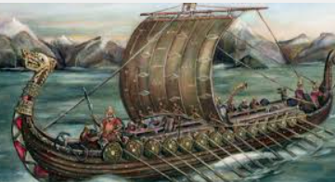
Please complete at least one task per half term – we look forward to seeing your projects!
DT/Science – Make a model of a machine that uses forces to work. How does a submarine sink even though it is full of air? Investigate…
History – Vikings - Make a WANTED poster about a legendary Viking character or construct a Viking longboat, however you choose in lego, cardboard or cake!
D&T – Research about different soups. Can you find recipes for soups from different countries? Look at the ingredients in different soups – either on cans of soup or recipes online. What ingredients are used in lots of different soups? Why are they used? Present your research either as a poster or leaflet.
ICT – Create a power point on any of the above topics. Insert photographs and images, use different fonts, animation and sound.
PSHE – Plan some Kindness Actions as part of ‘Power from Good’ in your local community. Document the impact in some way e.g. photos, drawings, quotes
Art – Create some colourful art in the style of Wassily Kandinsky

English
- Read at least 15 min every day
- Learn weekly spellings
- Complete weekly Comprehension
St Edmund’s Homework Menu
Autumn 2025
Maths
- Practise recall of times tables: Prime numbers up to 30 for Yr 5 and 100 for Yr 6
- Complete weekly times table practice

