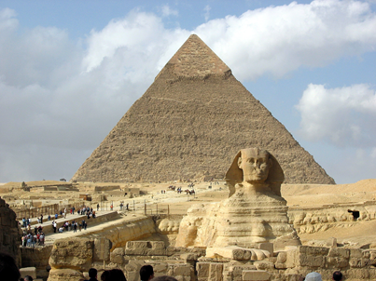
English
- Read at least 15 min every day
- Learn weekly spellings
- Complete weekly Comprehension
Please complete at least one task per half term
Science –Circulation, exercise and lifestyle - investigate your heart rate... can you monitor your pulse rate during a range of different activities? What do you notice? How does it vary from your resting heart rate? Can you compare pulse rates within your family? Can you create a table and feedback to the class about your findings? Here's information about how to find your pulse rate: https://www.ucsfbenioffchildrens.org/medical-tests/pulse
History – Ancient Civilisations (Ancient Egypt, Indus Valley, Sumer & Shang Dynasty):Research an aspect of life; clothing, weapons, food, housing, ancient sites, artefacts and produce a power point, poster, leaflet or object.
Geography – Research the areas where the Ancient Civilisations developed – climate, terrain, mountains, rivers. Compare and contrast .
D&T - 'Design a board game with a moving part. This could be a spinner to decide moves, some form of pop-up element, a flipper to move your playing piece or something else. Draw your game design and plan how you could make the moving part.'
ICT – Create a power point on any of the above topics. Insert photographs and images, use different fonts, animation and sound.
PSHE – Rules, rights and responsibilities - Find out more about voting and the voting system. How have our rights to vote changed in this country and why should it be your responsibility to vote when you turn 18? Find out more about the Representation of the People Act in 1918.
Art – Research an artist for Black History month. Either produce a fact file on them, reproduce a piece of their work or your own piece in the style of the artist.

Maths
- Practise recall of KIRFs: Multiplication & Division facts revision 12 x 12
- Complete weekly maths homework
St Edmunds Homework Menu
Autumn 2024

