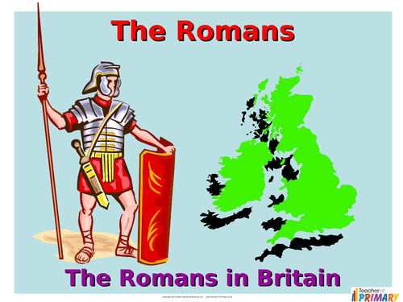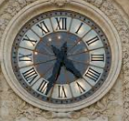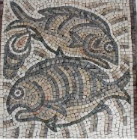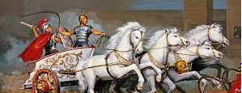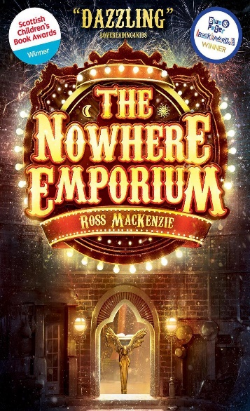
RE Hinduism Moksha: What spiritual pathways to Moksha are written about in Hindu scriptures? Christianity Salvation What did Jesus do to save human beings? Easter

Art
Roman themed art; mosaics and frescos. Sculpture – Henry Moore. Art in Literature - The Lady of Shallot
Geography How do Earthquakes and volcanoes occur? Where in the world do they occur?
History
The Roman Empire & it’s impact on Britain.. Looking at historical evidence and enquiry. Comparison of how life changed and developed over time.

ICT 3D modelling Introduction to Spreadsheets.
D & T Textiles: Designing and making phone case
PSHE
Financial Capability. Diversity and communities.

English – Daily Reading sessions. Book study: The Nowhere Emporium. Poetry, Fiction and Non Fiction texts. Please read every day and continue to practise spellings for homework. Comprehension homework on Wednesdays.
PE
Dance, Gymnastics & Hockey

Science Materials and their properties. Irreversible and reversible changes.

Maths – multiplication and division, ratio, and algebra (Year 6), percentages, decimals, measurement, statistics and problem solving. Please continue to practise quick recall of times tables for homework.
St Edmund Class Spring 2024

