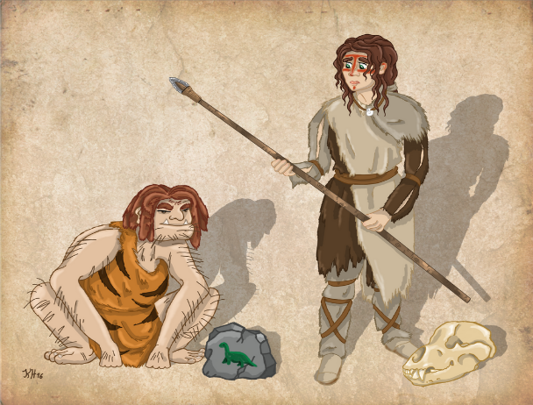
Topic – please complete at least one task per half term
Science – Forces: can you investigate the science behind hovercrafts?… How is air resistance involved? You might like to research how they work or even create your own (with the help of an adult). ScienceSparks.com has some interesting ideas about how to do this… Perhaps you could film your investigation and post it on Seesaw?
History – Stone Age to Iron Age: Create an Iron Age house/ fort
Research an aspect of life; clothing, weapons, food, housing, ancient sites etc
Geography – Locational knowledge – North America; research one of the countries in North America or create a fact file about some physical and human features of North America
ICT – Create a power point on any of the above topics. Insert photographs and images, use different fonts, animation.
PSHE – Beginning and Belonging: Create a family tree.
Art – Research a female artist of your choice. Create a Stone Age headdress

English
- Read every day 15mins
- Learn spellings
- Complete weekly Comprehension
Maths
- Play Sumdog
- Practise recall of KIRFs
- Complete any maths homework
St Edmunds Homework Menu
Autumn 2023

