ICT
Coding using the crumble kit – making computerised robots
e.g https://www.youtube.com/watch?v=v6wfa_VPS9I
History
Local Study – Why are Ely and Cambridge cities?
What impact have the churches/ cathedrals had on the history of the cities?
When was the church built in Dry Drayton?

St Edmunds Summer 2023

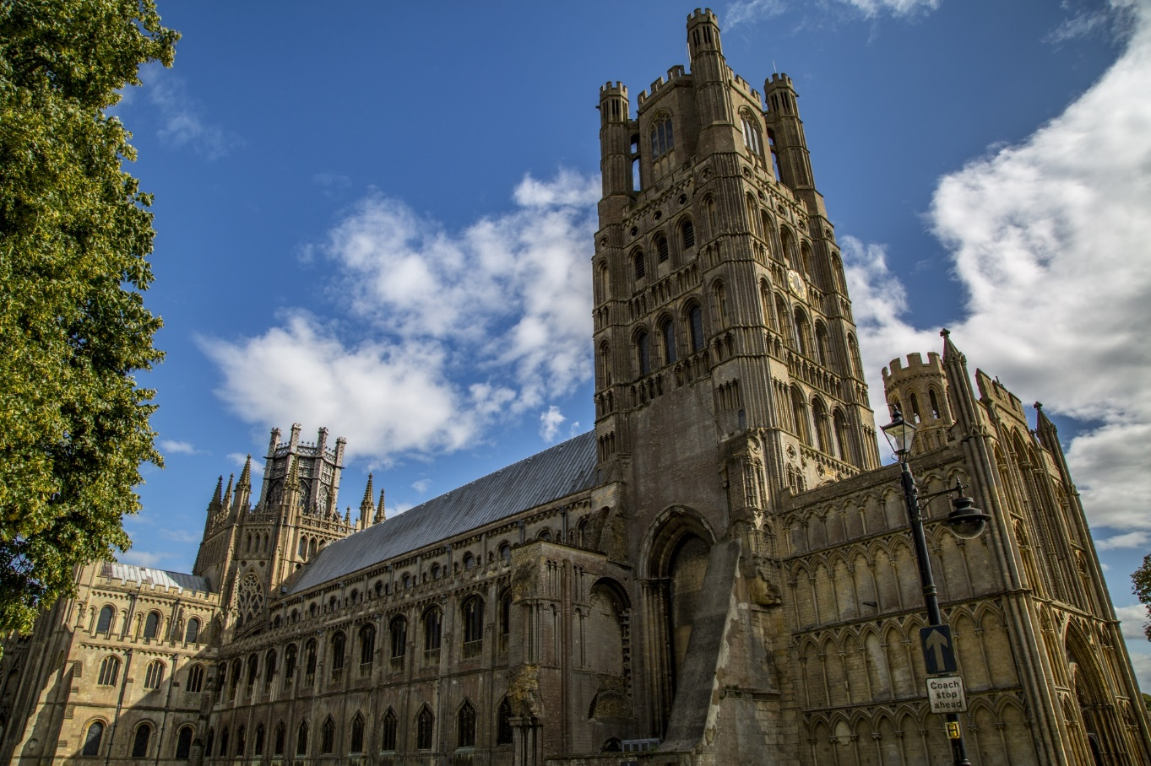
PSHE
Managing Change
Relationships and Sex education
Year 5 – Puberty
Year 6 – Puberty, sexual reproduction and loving relationships.
Maths
Year 5 Properties of Shape/ Position and Direction
Year 6 Revision of calculation
Properties of Shape /Position and Direction
English
Fiction – Holes
Poetry – AA Milne & T.S. Eliot
Non Fiction – Instructional writing (creating digital art) & non-chronological reports linked to local studies
PE
Swimming
Tennis
Athletics

Geography
Use the eight points of a compass, four and six-figure grid references, symbols and key (including the use of Ordnance Survey maps) to build their knowledge of the United Kingdom and the wider world

Use fieldwork to observe, measure, record and present the human and physical features in the local area using a range of methods, including sketch maps, plans and graphs, and digital technologies (link to local history study)

RE Islam Tawhid How does tawhid create a sense of belonging to the Muslin community?
Christianity: Creation and science: Conflicting or complementary?

Music
Ukulele/Djembe lessons – playing and performing
Learning songs for KS2 production
Science
- Animals inc. humans. describing development and change towards old age
- Working Scientifically projects
Art
Local Artists – research and record
Photography – observe and capture

