History
Local Study – World War 2
Battle of Britain
Significance of the Blitz
What impact did WW2 have on the role of women?

St Edmunds Spring 2023
ICT
Create vector drawings. Learn how to use different drawing tools to help them create images

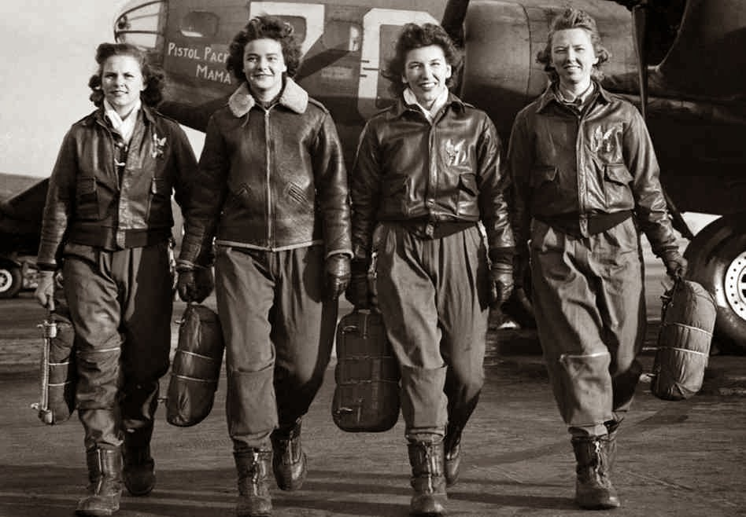
Geography
Food and Farming
Human geography, including: types of settlement and land use, economic activity including trade links, and the distribution of natural resources including energy, food, minerals and water (link to rationing in WW2)
English
Fiction – Goodnight Mr Tom
Poetry – Battle of Britain
Non Fiction – letters/diaries/ newspapers
RE
Kingdom of God – what kind of King is Jesus?
Easter
Music
A New Year Carol by Benjamin Britten
War Time songs
Glenn Miller
Science
Electricity: Exploring electrical circuits; switches, volume of buzzers and brightness of bulbs.
Maths
Year 5 Fractions/ Decimals & Percentages
Year 6 Ratio/ Decimals & Percentages/ Algebra
Art
Cubism - Pablo Picasso
Propaganda – War Posters, Fougasse
Paintings, murals - Gustav Klimt

PE
Dance
Gym
PSHE
Diversity and Communities
Drug Education
Children’s Mental Health Week

