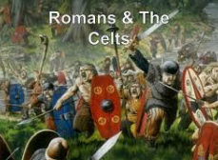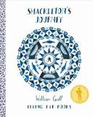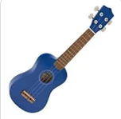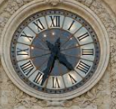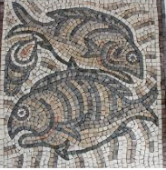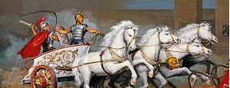
English – Daily Guided Reading sessions. Shackleton’s Journey by William Grill. Poetry, Fiction and Non Fiction texts. Please read every day and continue to practise spellings for homework. Year 6 – Reading Comprehension homework.
Maths – multiplication and division, ratio, and algebra (Year 6), percentages, decimals, measurement, statistics and problem solving. Please continue to practise quick recall of times tables for homework.
ICT
Data and information collection and presentation. Scratch for coding
Art
Roman themed art; mosaics and frescos.
St Edmund Class Spring 2020
History
The Celts and the Romans. Looking at historical evidence and enquiry. Comparison of how life changed and developed over time.

Science
The circulatory system.

Music Ukulele, xylophone playing to learn about notation, composition.
Songs and music for Easter.

PSHE
Drug Education-Life Education Bus. Diversity and communities.

RE
Creation. Fall. Easter.

PE
Hockey and Netball in preparation for tournaments.

