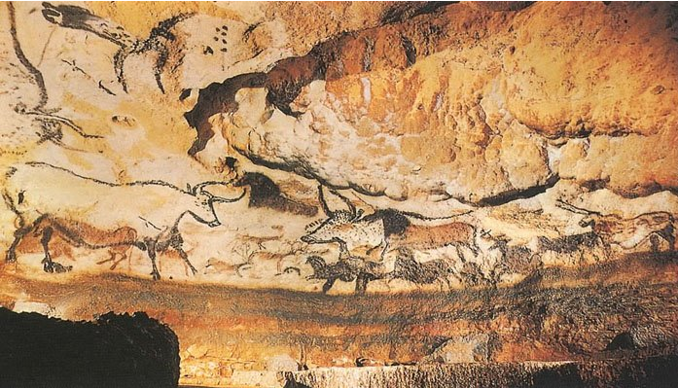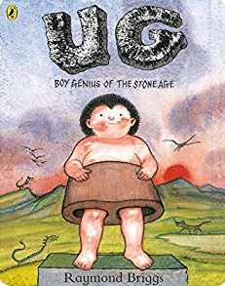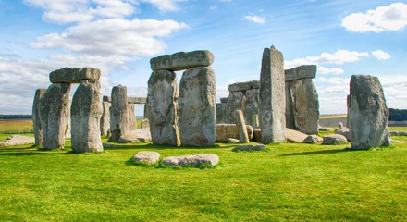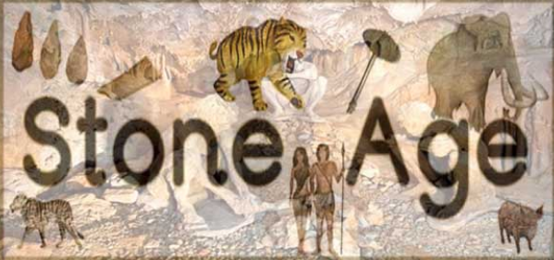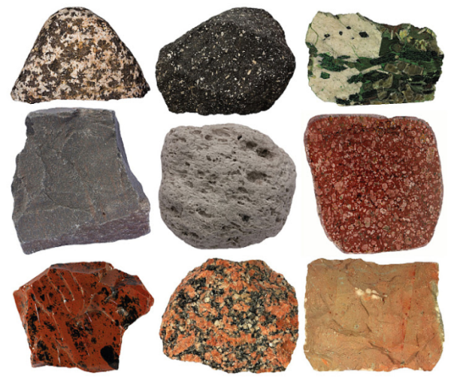
St Etheldrea’s Class Autumn 2019
Maths – Place Value. Addition, subtraction, multiplication and division. Please practice quick recall of number facts and times tables for homework.
History
The Stone Age through to Iron Age. Looking at historical evidence and enquiry. Comparison of how life changed and developed over time.

ICT
Internet Safety.
Key Skills.
ICT in the Environment.

Music Ukulele and singing
Songs and music for harvest and Christmas.

PSHE
Classroom and school rules. Adults who keep us safe. Treating others with respect. Kindness week.

Ukulele and singing.
Songs and music for harvest and Christmas

Art
Sketching, observational drawing, using different mediums. Collage, stone necklaces and printing.

RE
Our school prayers.
Creation and God.

PE
Football, netball and gym on Wednesday afternoon.

English – Daily Guided Reading sessions. Ug Boy Genius of the Stone Age. Poetry, Fiction and Non Fiction texts. Please read every day for homework.

