Literacy
*Write a Stone Age story
*Create an estate agents’ leaflet to sell a cave
*Write a newspaper report on the discovery of an ancient site
*Produce a visitor’s guide for a site or museum you have visited.
Geography
Visit an ancient site and create a visitors’ guide.
Find out the best places to build settlements locally and why.
- Produce a map of local/national sites.
Art
*Make a stone necklace
*Stone Age Cave Art
*Represent Stone Henge
*Create a Celtic design

D&T
*Build a biscuit Stonehenge
*Design and make an Iron Age Roundhouse
*Design some clothes for UG
*Build a new shelter for Stig

Stone Age to Iron Age
KS2 Termly Homework Pick and Mix.
Choose 1, 2 or more of the activities to complete and bring in during Wk beginning Mon 18th November.

Music
*Find out about prehistoric instruments or music
*Create your own piece of Stone Age music .
*Write a song, lullaby or rap.

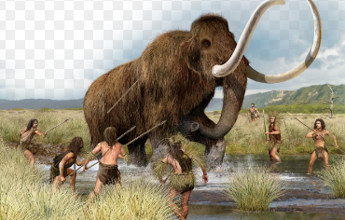
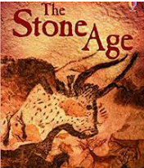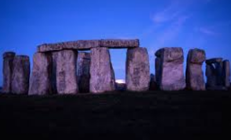
Use your imagination...make a necklace, design a language, be inspired!

