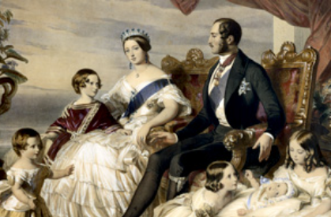
English
- Read at least 15 min every day
- Learn weekly spellings
- Complete weekly Comprehension (Mon)
Maths
Multiplication & Division facts revision 12 x 12 on TT Rock stars

Please complete at least one task per half term
Science –Circulation, exercise and lifestyle - investigate your heart rate... can you monitor your pulse rate during a range of different activities? What do you notice? How does it vary from your resting heart rate? Can you compare pulse rates within your family? Can you create a table and feedback to the class about your findings? Here's information about how to find your pulse rate: https://www.ucsfbenioffchildrens.org/medical-tests/pulse
History – Victorians – Can you visit a Cambridge Museum or gallery – The Fitzwilliam, built at the turn of the Victorian era and famous for the obsession with Greek and Roman architecture at that time. Can you find out about the Victorian Lions folklore? What is it imagined that the stone lions do by night? … Can you look out for the stone bust of Queen Victoria or find one of several Victorian paintings to sketch e.g. The Twins (1876) by John Everett Millais. The Museum of Cambridge could also be worth a visit where you can walk through a reconstructed Victorian home.
Geography – Create a map of the United Kingdom, you may use collage from magazines or scrap paper. Label places that you have been either with words or you might choose a symbol or drawing to remind yourself of time you spent there. Talk to your family about their favourite places and add them to the map if you wish.
D&T - 'Design a board game with a moving part. This could be a spinner to decide moves, some form of pop-up element, a flipper to move your playing piece or something else. Draw your game design and plan how you could make the moving part.'
ICT – Create a power point on any of the above topics. Insert photographs and images, use different fonts, animation and sound.
PSHE – UK Kindness Week is coming up in November, make a community pledge or journal your acts of kindness and the impact they have had on you and others around you
Art – Explore the artwork and designs of overlooked Victorian female artists https://www.christies.com/en/stories/beyond-the-brotherhood-female-artists-of-the-victorian-era-4aa70b11d3874794ac5142defd15b3d2 recreate one of their styles.

St Edmunds Homework Menu
Autumn 2026

