St Etheldreda homework pick n mix
Summer 2024

English:  - Read for at least 15 minutes per day  - Complete weekly spelling homework  - Complete weekly comprehension homework | Maths:  - Learn and practise times tables  - Play SumDog games
Topic – Please complete at least one task per half term:

Science:
Make some shadow puppets (humans/animals/objects) and use them to either tell a story or to teach us some science.
We will also be learning about states of matter. See if you can use all of these states while baking or cooking a meal: solids, liquids, gases, heating, cooling and melting point.
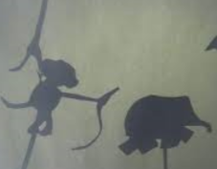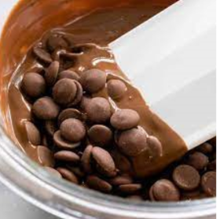

History – Anglo-Saxons - create a wanted poster for a Saxon criminal! What did they do? What form will the trial take? What might the punishment be? Draw a mugshot to make the poster stand out. You might find this information useful: https://m.youtube.com/watch?v=wk6h9uHtFLc
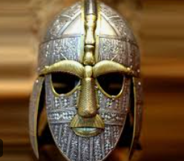
RE – research the Muslim place of worship (Mosque). You could make a PowerPoint or leaflet, or maybe you could paint a picture and label it, or perhaps you could make a model. You could visit The Cambridge Central Mosque for inspiration.
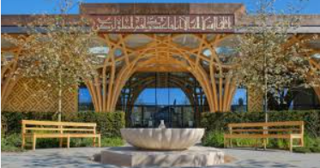
PSHE – draw/create an ‘Eatwell’ plate to show a healthy plate. You could draw the foods, or use pictures from magazines, or even create a model plate.
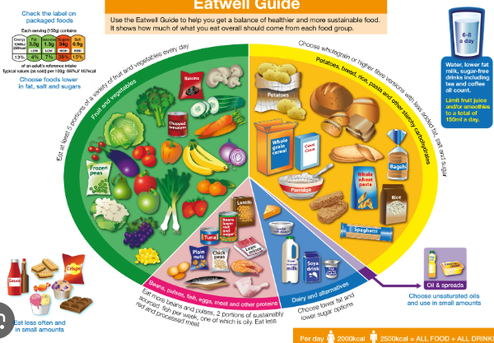
DT - find out what ingredients grow in a particular country. Design a meal using these ingredients. You could choose to make this meal and take a photo of what you've cooked.

