Art and DT
- Draw or create a mosaic.
- Design a Toga.
- Design a Roman shield.
- Draw or paint a Roman scene.
- Build a Roman villa.
- Build a Roman chariot.
- Design a Roman sandal.
- Research a Roman menu.
- Put together a PowerPoint of an aspect of Roman life.

Geography
- Find Rome in an atlas or on a map and write a visitors’ guide.
- Research the Roman Empire and create a fact sheet.
- Write a weather report for Rome.
- Research Mount Versuvius or another volcano.
History/Literacy
- Write a story set in Roman times.
- Create an estate agents’ leaflet to sell a Roman villa.
- Write a newspaper report about the volcanic eruption on Pompeii.
- Produce a Non-Chronological report on an aspect of Roman life.

Maths
- Can you learn the Roman Numerals?
How far can you go?
- Make a symmetrical mosaic. What shapes have you used?
- Plan a cost a holiday to Rome for your family.

St Etheldreda Termly Homework Pick and Mix.
Please complete at least one activity and also read your school reading book every evening, complete weekly comprehension and spelling homework and practise your times tables.

Science
- Produce a leaflet, diary entry or PowerPoint about the day in the life of a healthy tooth.

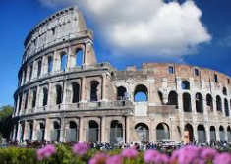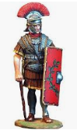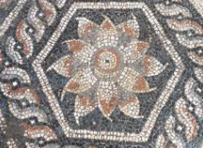
Use your imagination...make some jewellery, research Roman society, be inspired!

