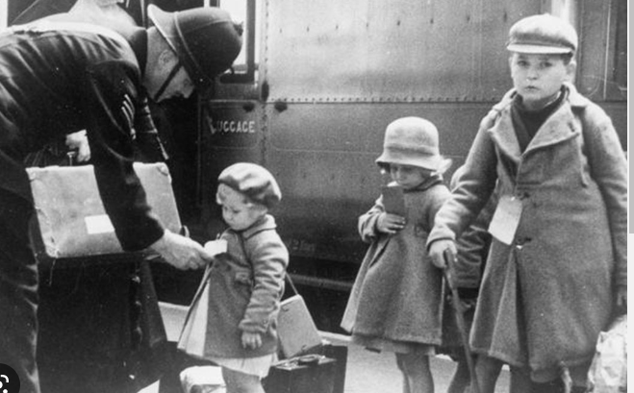
Science
Animals including humans (nutrition, identification and purpose of skeletons and muscles)
National Science Week – working scientifically

‘Working scientifically’ skills focus

RE

Hinduism - Dharma
How does the story of Rama and Sita inspire Hindus to follow their dharma?
Christianity - Salvation
Why do Christians call the day Jesus died ‘Good Friday’?

English – Fiction – Plays
Poetry – Poetry on a theme
Non Fiction – recount – letters/diaries

Maths –
Addition, subtraction,
multiplication and division.
Fractions

PSHE
Diversity and communities
Drug Education
Children’s mental health week

ICT
Photo Editing
Branching Databases

PE
Dance
Gym
Music

Songs –Stop.
Lean on me.

Ukulele/djembe lessons. Xylophone playing to learn about notation and composition

History
Local study – World War 2
What impact did World War 2 have on our locality?
Art
Cubism - Pablo Picasso

Propaganda – War Posters, Fougasse

Paintings, murals - Gustav Klimt

Geography
Physical geography – food and farming

Where does food come from?

St Etheldreda Spring 2023

