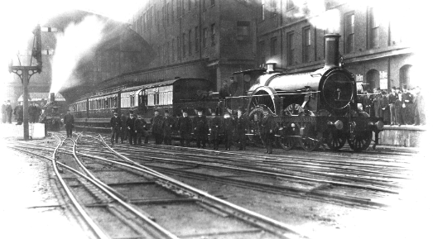
ICT
ICT safety, ICT skills using word,
Scratch for coding

Science
Forces and Magnets.
Conductors and Insulators.
English – Fiction – The Tin Forest by Helen Ward
Poetry – Haiku/Tanka
Non Fiction – Non-chronological reports

RE
Christianity - Creation
What do Christians learn from the creation story?
Christianity - Incarnation
What is Trinity?

Music
Singing - Mamma Mia.
Glockenspiel, Ukulele and djembe lessons
Christmas songs

PSHE
Rights, Rules and Responsibilities
My emotions
Kindness week/Anti-bullying
Emotional vocabulary

PE
Football
Netball
Tag Rugby
Gym-pathways and landing

Geography
Locational knowledge
Counties and cities in the have UK – land-use patterns and understanding how these changed over time.
How has economic activity changed over time?

Art
Repeating patterns – William Morris
Architects – Brunel
Pointillism and Aboriginal art

Maths – Place Value.
Addition, subtraction, multiplication and division.
Length and Perimeter.
St Etheldreda Autumn 2022
History
The Railways
How did transport change life in Victorian England?
Developing a chronology of how the railways have developed over time.
Why is there a station in Cambridge?

